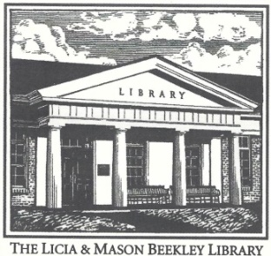

Licia & Mason Beekley Community Library
10 Central Ave. New Hartford, CT 06057
Staff@beekleylibrary.org
860-379-7235

Electronic Device Lending Policy – Hot Spots

1.) Hot Spots may be borrowed by residents 18 years and older with Beekley Library cards in good standing that
can verify their identity with a valid photo ID.

2.) Hot Spots may be reserved. If there are no pending reservations, one renewal is permitted. Our lending agreement must be filled out and signed.

3.) One Hot Spot may be borrowed per household at one time.

4.) The Hot Spot kit includes: (1) Lenovo Hot Spot 300e 2nd Gen, (2) 2 part Charging Cable, (3) Zipper Case.

6.) The loan period is fourteen (14) days.

7.) Hot Spots must be returned in person to the Beekley Library only.

7.) Patrons are encouraged to wait until the Hot Spot kit is checked in by a staff member at the Circulation Desk. To ensure the safety of the equipment - DO NOT return the Hot Spot and accessories in the book drop or to another library. Doing so will be treated as an instance of a late return and may result in billable device damage.

8.) Fines for overdue Hot Spots are $5.00 per day, not counting the days the library is closed. An “on-time” return is defined as a Hot Spot that is returned to a library staff member prior to closing on the due date.

9.) Patrons shall not alter the Hot Spot in any way, including (but not limited to) altering the settings of the device, adding programs to the device, or placing stickers or markings on the device, etc. The Library is not responsible for any liability, damages or expenses resulting from the use or misuse of a borrowed device, connection of the device to other electronic devices, or data loss resulting from use of the device.

10.) Any use of a Hot Spot for illegal purposes, unauthorized copying of copyright-protected material in any form, or transmission of threatening, harassing, defamatory or obscene materials is strictly prohibited.

11.) Patrons will immediately report any hardware or software problems to Library staff.

12.) The patron is responsible for damage to or loss of the Hot Spot or accessories as a result of accident, theft, misuse or neglect. Lost or damaged Hot Spots and/or accessories will be charged up to the full replacement cost of $180.00. Library staff will assess each device upon return and, if necessary, charge the patron accordingly –
Hot Spot - $150, 2 part Charging Cable - $15, Zipper Case - $15.

13.) IMPORTANT - Files cannot be permanently saved to Hot Spots.

